***1.INTRODUCTION***

**1.1 What is .Net?**

.NET Framework (pronounced dot Net) is a software framework developed by Microsoft that runs primarily on Microsoft Windows. It includes a large class library named Framework Class Library (FCL) and provides language interoperability (each language can use code written in other languages) across several programming languages. Programs written for .NET Framework execute in a software environment (in contrast to a hardware environment) named Common Language Runtime (CLR), an application virtual machine that provides services such as security, memory management, and exception handling. (As such, computer code written using .NET Framework is called "managed code".) FCL and CLR together constitute .NET Framework.

FCL provides user interface, data access, database connectivity, cryptography, web application development, numeric algorithms, and network communications. Programmers produce software by combining their source code with .NET Framework and other libraries. The framework is intended to be used by most new applications created for the Windows platform. Microsoft also produces an integrated development environment largely for .NET software called Visual Studio.

.NET Framework began as proprietary software, although the firm worked to standardize the software stack almost immediately, even before its first release. Despite the standardization efforts, developers, mainly those in the free and open-source software communities, expressed their unease with the selected terms and the prospects of any free and open-source implementation, especially regarding software patents. Since then, Microsoft has changed .NET development to more closely follow a contemporary model of a community-developed software project, including issuing an update to its patent promising to address the concerns.

**1.2Features of .Net**

Now that we know some basics of .NET, let us see what makes .NET a wonderful platform for developing modern applications.

• **Rich Functionality out of the box**

.NET framework provides a rich set of functionality out of the box. It contains hundreds of classes that provide variety of functionality ready to use in your applications. This means that as a developer you need not go into low level details of many operations such as file IO, network communication and so on.

• **Easy development of web applications**

ASP.NET is a technology available on .NET platform for developing dynamic and data driven web applications. ASP.NET provides an event driven programming model (similar to Visual Basic 6 that simplify development of web pages (now called as web forms) with complex user interface. ASP.NET server controls provide advanced user interface elements (like calendar and grids) that save lot of coding from programmer’s side.

• **OOPs Support**

The advantages of Object Oriented programming are well known. .NET provides a fully object oriented environment. The philosophy of .NET is – “Object is mother of all.” Languages like Visual Basic.NET now support many of the OO features that were lacking traditionally. Even primitive types like integer and characters can be treated as objects – something not available even in OO languages like C++.

• **Multi-Language Support**

Generally enterprises have varying skill sets. For example, a company might have people with skills in Visual Basic, C++, and Java etc. It is an experience that whenever a new language or environment is invented existing skills are out dated. This naturally increases cost of training and learning curve. .NET provides something attractive in this area. It supports multiple languages. This means that if you have skills in C++, you need not throw them but just mould them to suit .NET environment. Currently four languages are available right out of the box namely – Visual Basic.NET, C# (pronounced as C-sharp), Jscript, .NET and Managed C++ (a dialect of Visual C++). There are many vendors that are working on developing language compilers for other languages (20+ language compilers are already available). The beauty of multi-language support lies in the fact that even though the syntax of each language is different, the basic capabilities of each language remain at par with one another.

• **Multi-Device Support**

Modern lift style is increasingly embracing mobile and wireless devices such as PDAs, mobiles and handheld PC’s. . . .NET provides promising platform for programming such devices. .NET Compact Framework and Mobile Internet Toolkit are step ahead in this direction.

• **Automatic memory management**

While developing applications developers had to develop an eye on system resources like memory. Memory leaks were major reason in failure of applications. .NET takes this worry away from developer by handling memory on its own. The garbage collector takes care of freeing unused objects at appropriate intervals.

• **Compatibility with COM and COM+**

Before the introduction of .NET, COM was the de-facto standard for componentized software development. Companies have invested lot of money and efforts in developing COM components and controls. The good news is – you can still use COM components and ActiveX controls under .NET. This allows you to use your existing investment in .NET applications. .NET still relies on COM+ for features like transaction management and object pooling. In fact it provides enhanced declarative support for configuring COM+ application right from your source code. Your COM+ knowledge still remains as a valuable asset.

• **No more DLL Hell**

If you have worked with COM components, you probably are aware of “DLL hell”. DLL conflicts are a common fact in COM world. The main reason behind this was the philosophy of COM – “one version of component across machine”.

Also, COM components require registration in the system registry. .NET ends this DLL hell by allowing applications to use their own copy of dependent DLL’s. So, .NET components do not require any kind of registration in system registry.

• **Strong XML support**

Now days it is hard to find a programmer who is unaware of XML. XML has gained such a strong industry support that almost all the vendors have released some kind of upgrades or patches to their existing software to make it “XML compatible”. Currently, .NET is the only platform that has built with XML right into the core framework. .NET tries to harness power of XML in every possible way. In addition to providing support for manipulating and transforming XML documents, .NET provides XML web services that are based on standards like HTTP, XML and SOAP.

• **Ease of deployment and configuration**

Deploying windows applications especially that used COM components were always been a tedious task. Since .NET does not require any registration as such, much of the deployment is simplified. This makes XCOPY deployment viable. Configuration is another area where .NET – especially ASP.NET – shines over traditional languages. The configuration is done via special files having special XML vocabulary. Since, most of the configuration is done via configuration files, there is no need to sit in front of actual machine and configure the application manually. This is more important for web applications; simply FTP new configuration file makes necessary changes.

**1.2.1 Application Framework**

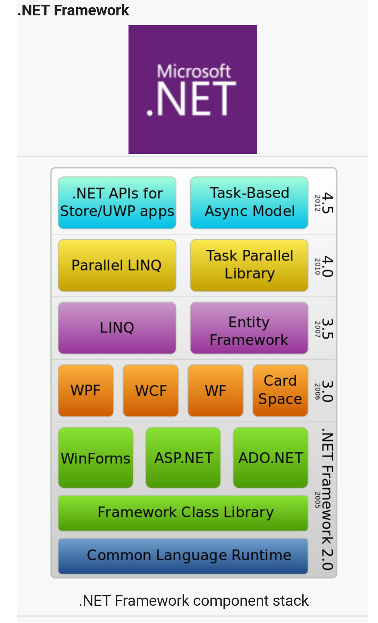

**1.3 Motivation**

The KBC Application is one of the most interactive Gaming Application. The previous conventions followed for taking data was very tedious task and requires a lot of paper work. It was not automated and so handling and maintaining the system was a tough job. This Application helps the user to enhance the brainstorming session. So there was a need to build up the I.Q. level of the individual. It also helps the user to automate the Application and to reduce the manual effort needed in storing the records and maintaining it.

**1.4 Objective**

* Develop a system that can replace the manual System.
* Develop a database which stores user details & personal details.
* Give reliable search facility for the users
* Administrator & users should have separate logins.
* Create an easy to understand user friendly environment.
* Attractive user interfaces to navigate through the system for the users.
* Develop the system documentation with detailed UML specifications.

***2.GENERAL DESCRIPTION***

**2.1 Introduction**

Visual Basic .NET (VB.NET) is a multi-paradigm, object-oriented programming language, implemented on the .NET Framework. Microsoft launched VB.NET in 2002 as the successor to its original Visual Basic language. Although the ".NET" portion of the name was dropped in 2005, this article uses "Visual Basic [.NET]" to refer to all Visual Basic languages releases since 2002, in order to distinguish between them and the classic Visual Basic. Along with Visual C#, it is one of the two main languages targeting the .NET framework.

Microsoft's integrated development environment (IDE) for developing in Visual Basic .NET language is Visual Studio. Most of Visual Studio editions are commercial; the only exceptions are Visual Studio Express and Visual Studio Community, which are freeware. In addition, .NET Framework SDK includes a freeware command-line compiler called vbc.exe. Mono also includes a command-line VB.NET compiler.

**2.2 Product Perspective**

**1) Gaming**

This product is based on gaming application where user can interact with it.

**2) User Interface**

The user interface (UI), in the industrial design field of human–computer interaction, is the space where interactions between humans and machines occur. The goal of this interaction is to allow effective operation and control of the machine from the human end, whilst the machine simultaneously feeds back information that aids the operators' decision-making process. Examples of this broad concept of user interfaces include the interactive aspects of computer operating systems, hand tools, heavy machinery operator controls, and process controls. The design considerations applicable when creating user interfaces are related to or involve such disciplines as ergonomics and psychology.

Generally, the goal of user interface design is to produce a user interface which makes it easy (self-explanatory), efficient, and enjoyable (user-friendly) to operate a machine in the way which produces the desired result. This generally means that the operator needs to provide minimal input to achieve the desired output, and also that the machine minimizes undesired outputs to the human.

**2.3 Contestants**

* The Contestants who have Membership logs in through his account and gets the details of their information taken by him and the contestants enrolled in the game.
* The Contestants can retrieve their information from the database through the recovery form.
* The Contestants can see the details of their score in the result form.

**3.REQUIREMENT AND ANALYSIS**

The proposed system will be efficient, low cost, scalable security system based computer application. It uses the Artificially Intelligent neural networks to identify the persons. After the decision making is completed it will authorize the user. Problem Definition The current system is as mentioned earlier very complicated and expensive as compared to the new system. It also wastes the precious time of the store workers. As store workers are humans and so prone to errors, there can be mistakes in any kind of report, sales etc. Only preventive measures are taking a double check to ensure these errors don’t happen which would again require extra time. Thus, the current system is in every way ineffective for handling store data in these days when time is more costly than anything and they also pose a threat to the environment when we are amidst a global crisis and in the need of a Green Revolution.

Features of New System The new system has been designed as per the user requirements so also fulfil almost all them.

* Quick Scheduling
* Immediate Results and Solutions
* Easy to Store and Retrieve Information
* Cost Effective

**3.1 Software Requirements**

It covers the functional requirement for the Application.

**3.2 Specific of the Project**

Once the analysis and design of the system has been done, it would be necessary to identify the data that are required to be processed to produce the outputs. Input is one of the most expensive phases of the operation of a computerized system and creates sometimes a major problem. Different type of problem with a system can usually be traced back to faulty input design method needless to say, therefore, that the input data are the lifeblood of a system and have to be analysed and designed with utmost care and consideration. Input design features can ensure the reliability of the system and generate correct reports form the accurate data. The input design also determines whether the user can interact efficiently with the system.

**Elements of Input**

Data Inaccurate input data are the most common cause of errors in data processing. Errors entered by data entry operators can be controlled by input design. Input data are collected and organized into groups of similar data. Once identified, appropriate input media are selected for processing.

**Input Data**

The goal of designing input data is to make data entry as easy, logical and error free from errors as possible. In entering data, operators need to know the following:

* The allocated space for each field.
* Field sequence, which much match that in the source document.
* When we approach input data design, we design the source document. Let us elaborate on each step.

**Source Documents**

Source data are captured initially on original paper or a source document. For example, a cheque written against an account is a source document. When it reaches the bank, it is encoded with special magnetic ink character recognition so that a reader that is part of the information system of the bank can process it. Therefore, source documents initiate a processing cycle as soon as they are entered into the system. Source documents may be entered into the system from punch cards, from diskettes, or even directly through the keyboard.

A source document should be logical and easy to understand. Each area in the form should be clearly identified and should specify for the user what to write and where to write it. A source document may or may not be retained in the proposed system. Thus, each source document may be evaluated in terms of. Its continued use in the proposed system. The extent of modification for the proposed system & Replacement by an alternative source document.

**Input Design**

The design of input play very significant role in getting the correct output. It covers all phases of input from creation of initial data (original recording) to actual entering the data to the system for processing. The input design is the link that ties the information system into the world of its users. Some features of design may vary depending on whether the system is batch-oriented or on-line. Here, we will discuss the various objectives of input design. They focus on:

* Controlling amount of input
* Avoiding delay
* Avoiding errors in data
* Avoiding extra steps
* Keeping the process simple

**Controlling Amount of Data**

An effective design controls the quantity of data for input for the following reasons:

* Firstly, data preparation and data entry operations depend on people. Since labour costs are high, the cost or preparing and entering data is also high. It is quite evident, then that reducing data requirements mean lowering costs through reduced labour expense.
* Secondly, the input phase of computing can be slow process and take many times longer than that needed by computers to carry out their tasks. In fact, the computer itself may sit idle until data is prepared and input for processing. By reducing input requirements, the analyst will speed the entire process from data capture to processing to provide result to users.

**Avoiding Delay**

When processing is delayed owing to data preparation or data entry, the cause is called a bottleneck. Avoid bottlenecks when designing input should always be one of the objectives of the analyst.

**Avoiding Errors in Data**

The third objective deals with errors. In one sense, the rate at which errors occur is dependent on the quantity of data. Since the lower the amount of data is inputted, there are fewer opportunities for the error to occur.

* Firstly, the analyst can reduce this number by reducing the volume of data dust must be entered for each transaction.
* Secondly, the analyst can also affect error rates of an operation through design. The manner in which data must be entered can reduce the chance of errors.
* Still, a third aspect of error control is the need to detect errors when they do occur. Checks and balances in the data entry programs, called input validation techniques, also detect errors input.

**3.3 General of the Project**

**Output Design**

Outputs of a system can take different forms. The most common are reports, displays on screen, printed forms etc. the outputs also vary in terms of their contents, type of stationery. Frequency and timing etc. besides, due consideration also need to be given as to who will use the output and for what purpose. All these points must be kept in mind while designing outputs so that the objectives of the system are met in the best possible way.

Outputs of a data-processing system can be placed into two categories:

* Application Output
* Operating Output

**Application Output**

These are the outputs desired out of the system to meet its objectives. These are of three types:

* Output as a basis for decision-making. This type of output is generally required by management for decision-making purposes.
* Output as a requirement to meet a functional objective. Invoices, Excise Gate Pass, Purchase Orders are the examples of such output.
* Statutory outputs: All organization is required to produce a certain amount of reports and forms as required by law.

**Operating Output**

These outputs are mainly generated for use of EDP staff and give various indications as to how the system operates. System logs, error messages, status indicators etc. are the examples of such output. These types of output are not concerned for the users.

***4. IMPLEMENTATION***

The Application is implemented according to three tier architecture. Three tier architecture is commonly known as Client-Server architecture, where Client is the consumer of the services, also the requester of services where as the server side is the provider of services. The third layer that is the middle layer that converts the users requests into server understandable form.

The server side comprises of the MySQL. The .Net API uses the PHP to connect to the database or server database.

***4.1 VB.Net API***

VB.Net Web API is a framework for building HTTP services that can be consumed by a broad range of clients including browsers, mobiles and tablets. It is very similar to VB.NET MVC since it contains the MVC features such as routing, controllers, action results, filter, model binders, IOC container or dependency injection. But it is not a part of the MVC Framework. It is a part of the core VB.NET platform and can be used with MVC and other types of Web applications like VB.Net Web Forms. It can also be used as an stand-alone Web services application.

Today, a web-based application is not enough to reach it's customers. People are very smart, they are using mobile, tablets etc. devices in its daily life. These devices also have a lot of apps for making the life easy. Actually, we are moving from the web towards apps world.

So, if you like to expose your service data to the browsers and as well as all these modern devices apps in fast and simple way, you should have an API which is compatible with browsers and all these devices.

For example twitter, Facebook and Google API for the web application and phone apps.

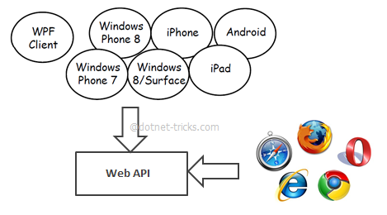

**4.2 SCREENSHOTS**

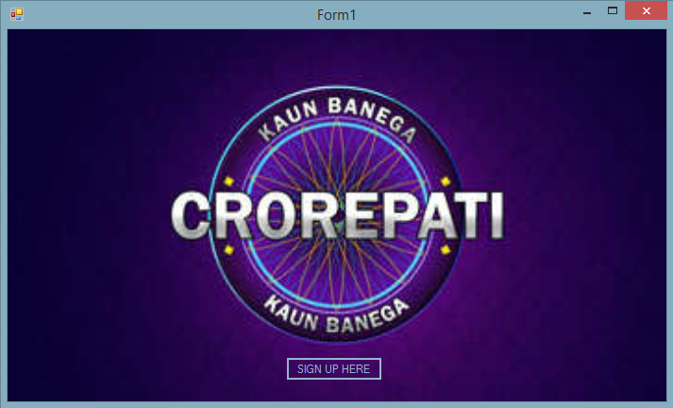

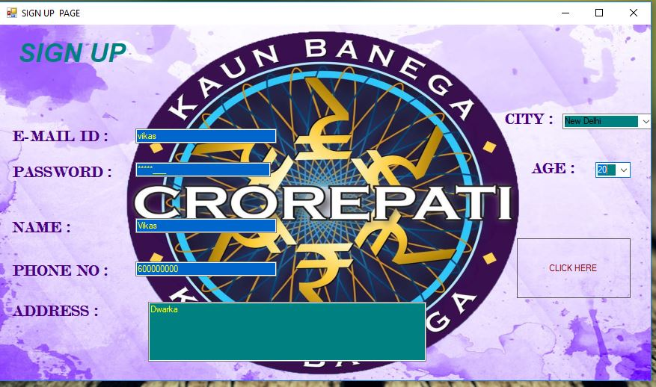

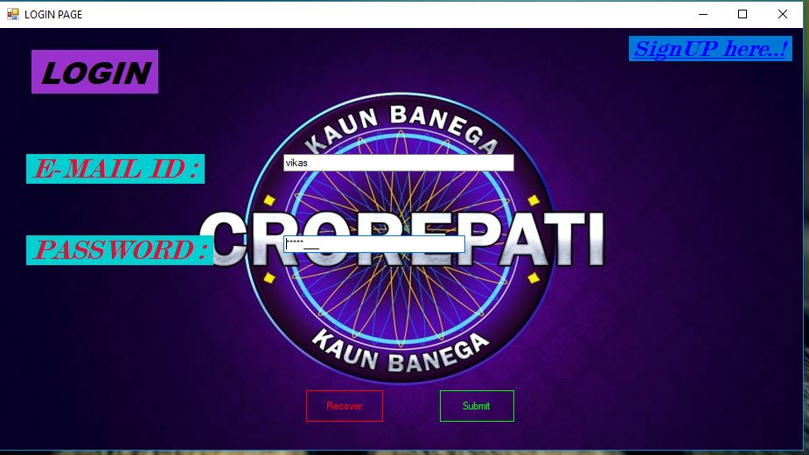

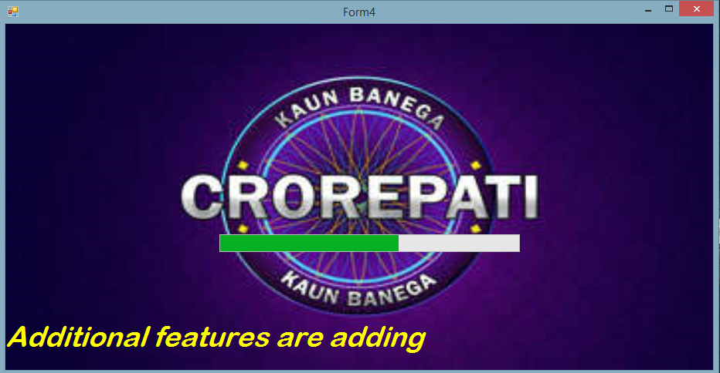

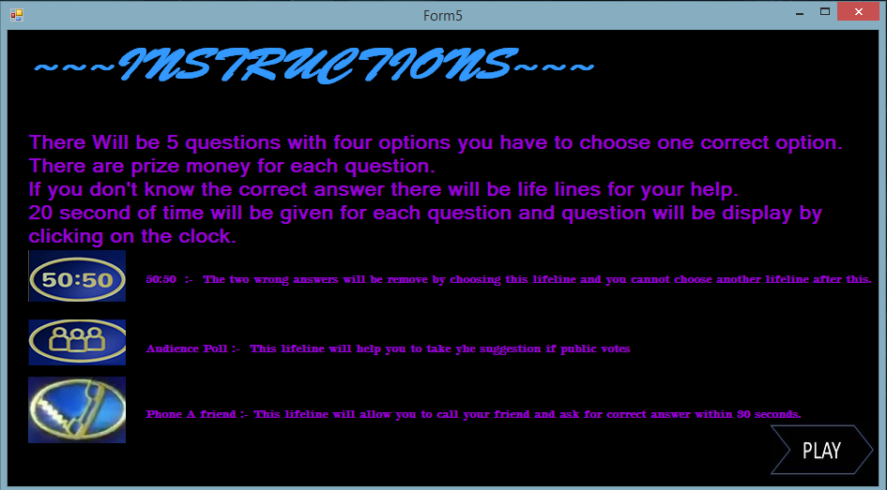

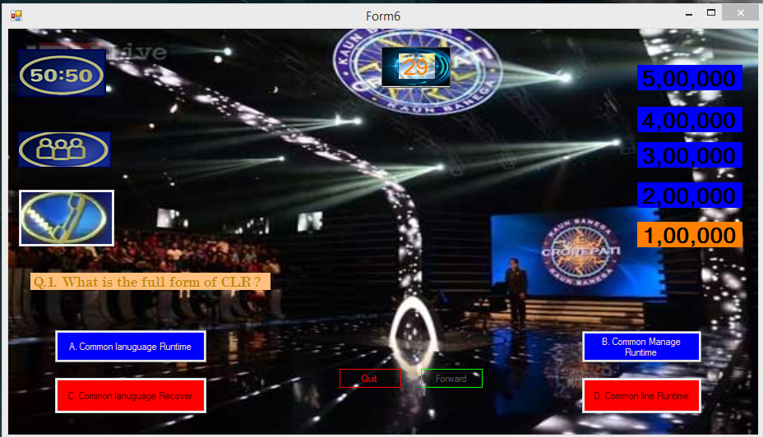

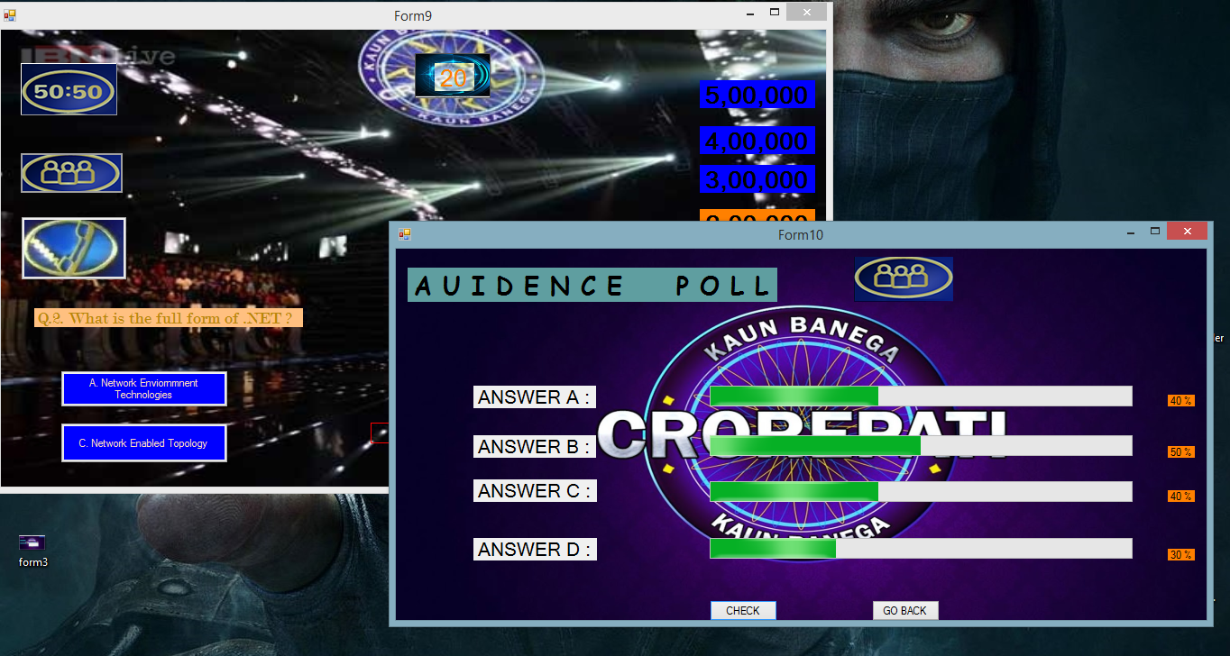

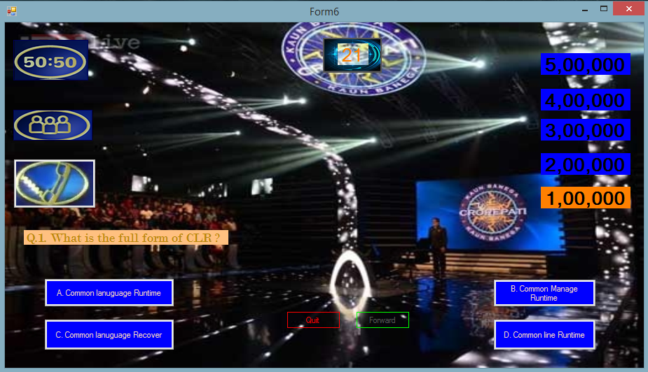

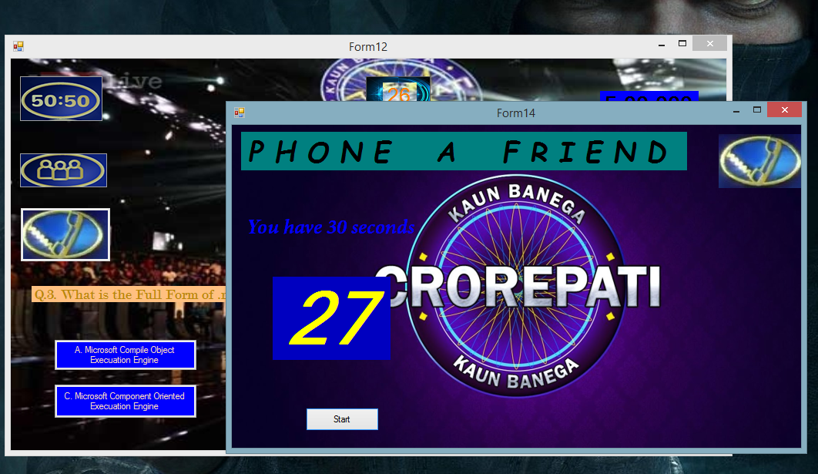

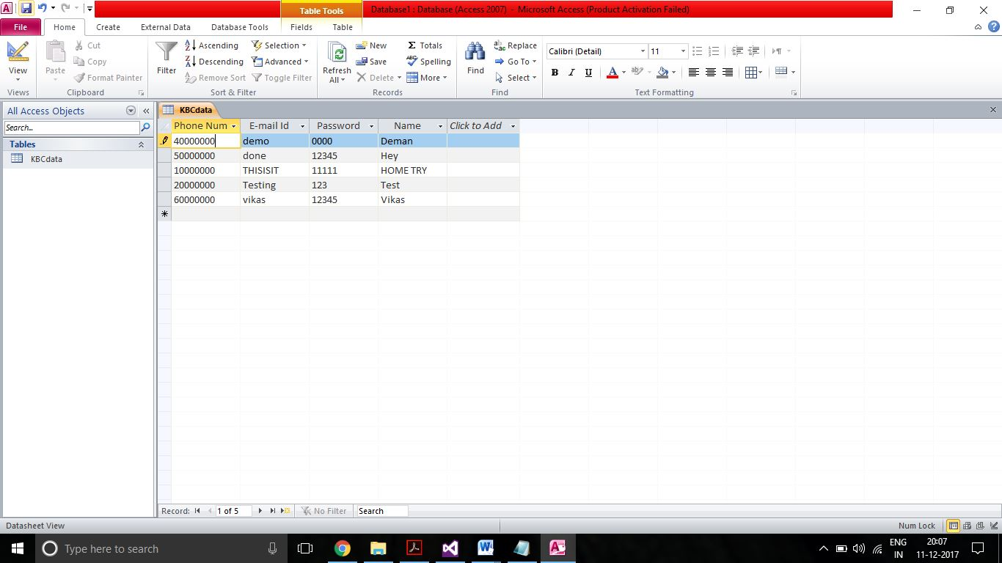

**5. SYSTEM DESIGN**

Design is a meaningful engineering representation of something that is to be built. Software design is a process through which the requirements are translated into a representation of the software. Design is the place where quality is fostered in software engineering. Design is the perfect way to accurately translate a customer’s requirement in to a finished software product. Design creates a representation or model, provides detail about software data structure, architecture, interfaces and components that are necessary to implement a system.

**5.1 Software Architecture**

**Home Page**

**Yes**

**Login Form**

**Invalid Username or Password**

**No**

*Figure 1 : System Design –Login*

**E-mail Id**

**Password**

**Name**

**Sign Up**

**Phone No.**

**Address**

*Figure 2: System Design – Sign Up Page*

**5.2 E R Diagram**

An entity relationship diagram (ERD) shows the relationships of entity sets stored in a database. An entity in this context is a component of data. In other words, ER diagrams illustrate the logical structure of databases.

The following are the ER Diagram of Application System:

NAME

**PHONE NUMBER**

PASSWORD

USER DETAILS

E-MAIL ID

CITY

ADDRESS

AGE

ASSIGNED

E-MAIL ID

PASSWORD

LOG IN

**5.3 Data Flow Diagram**

Several rules of thumb are used in drawing DFD’S:

1. Process should be named and numbered for an easy reference. Each name should be representative of the process.

2. The direction of flow is from top to bottom and from left to right. Data traditionally flow from source to the destination although they may flow back to the source. One way to indicate this is to draw long flow line back to a source. An alternative way is to repeat the source symbol as a destination. Since, it is used more than once in the DFD it is marked with a short diagonal.

3. When a process is exploded into lower level details, they are numbered.

4. The names of data stores and destinations are written in capital letters. Process and dataflow names have the first letter of each work capitalized.

A DFD typically shows the minimum contents of data store. Each data store should contain all the data elements that flow in and out. Questionnaires should contain all the data elements that flow in and out. Missing interfaces redundancies and like is then accounted for often through interviews.

Salient feature of DFD :

1. The DFD shows flow of data, not of control loops and decision are controlled considerations do not appear on a DFD.

2. The DFD does not indicate the time factor involved in any process whether the dataflow take place daily, weekly, monthly or yearly.

3. The sequence of events is not brought out on the DFD.

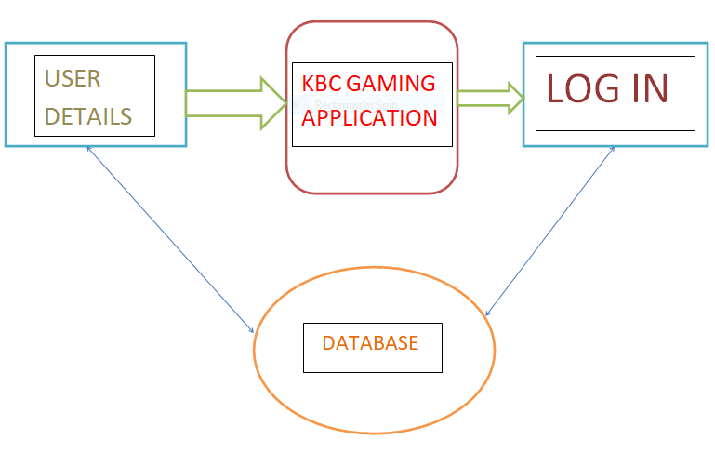

**6.TESTING**

Testing is the process used to help identify the correctness, completeness, security and quality of developed computer software. Testing is a process of technical investigation, performed on behalf of stakeholders, that is intended to reveal quality-related information about the product with respect to the context in which it is intended to operate. In general, software engineers distinguish software faults from software failures. Our project" Visual cryptography For Cheating Prevention” is tested with the following testing methodologies.

**6.1 Testing Methods**

The two different methods are static and dynamic. Dynamic testing needs the program to be executed completely before testing. This is a traditional concept where the faults detected at the end will be very hard to rectify. In static process the program is tested for each and every line and the testing process is allowed to pass through only after rectifying the occurred fault. These make this process more expensive, so a combination of both static and dynamic testing method.

**Mode of Testing**

It is necessary to select the test mode in which the testing method to be carried out. The two different modes are manual and automated tool. The real time projects needs frequent interactions. So, it is impossible to carry out the testing process by means of automated tool. Our project uses manual testing.

**Unit Test Technique**

This phase examines the techniques, assessment and management of unit testing and analysis. Testing and analysis strategies are categorized according to whether they goal is functional or structural or combination of these. It will assist a software engineer to define, conduct and evaluate unit tests and to assess new unit test techniques.

**System Testing**

Once the entire system has been built then it has to be tested against the "System Specification" to check if it delivers the features required. It is still developer focused, although specialist developers known as systems testers are normally employed to do it. In essence System Testing is not about checking the individual parts of the design, but about checking the system as a whole. In effect it is one giant component.

**Acceptance Testing**

Acceptance Testing checks the system against the "Requirements". It is similar to systems testing in that the whole system is checked but the important difference is the change in focus. Systems testing checks that the system that was specified has been delivered. Acceptance Testing checks that the system delivers what was requested. The customer, and not the developer should always do acceptance testing. The customer knows what is required from the system to achieve value in the business and is the only person qualified to make that judgment.

**Regression Testing**

This involves assurance that all aspects of an application system remain functional after testing. The introduction of change is the cause of problems in previously tested segments. It is retesting unchanged segments of the application system.

**7.CONCLUSION AND FUTURE WORK**

**7.1 Conclusion**

This project is successful in carrying out; it will help a person to know the management of passed year perfectly and vividly. It also helps in current all works relative transaction. It’s all program coding is easily understandable and user friendly. Its architectural diagram helps users to understand the project easily. Limitations and Future Scope of the System There are some limitations for the current system to which solution can be provided as a future development:

* This is just an Application Software, however Web version will also introduced later as further development.
* The application is not configured for multi-users at this time. So, only single user can perform a task at a time on the current system.
* In current version online facilities are not available so they have to come at store and order for any product or item however in upgraded version (web based) customers need not visit the store and can order online.
* In current System, Only Authenticated Users can access the application and register the customers however in further development Customers can register with the store themselves as online facilities will be available

**7.2 Future Work**

* The system can be further enhanced and several other functionalities can be added. The system can be made login independent. The present system logs in using Internet all the time.
* We can enhance the system by implementing offline mode login feature. The feature to update the questions at a later stage can also be implemented. The system can also be enhanced by using voice recognition feature of the .Net application.
* In future, Additional features activities will be announced like total users and live users monitoring, active and inactive users monitoring etc.
* In future, Membership of customer feature will be replace by promo code.

***6. BIBLIOGRAPHY***

* ***.Net Tutorials Point -*** <https://www.tutorialspoint.com/vb.net/>
* ***Microsoft VB.Net Tutorials Website –***

https://www.msdn.com/vb.net/

* ***.NET BLACK BOOK by Kogent Learning Solutions Inc.***